CONCEPTUAL DIAGRAM

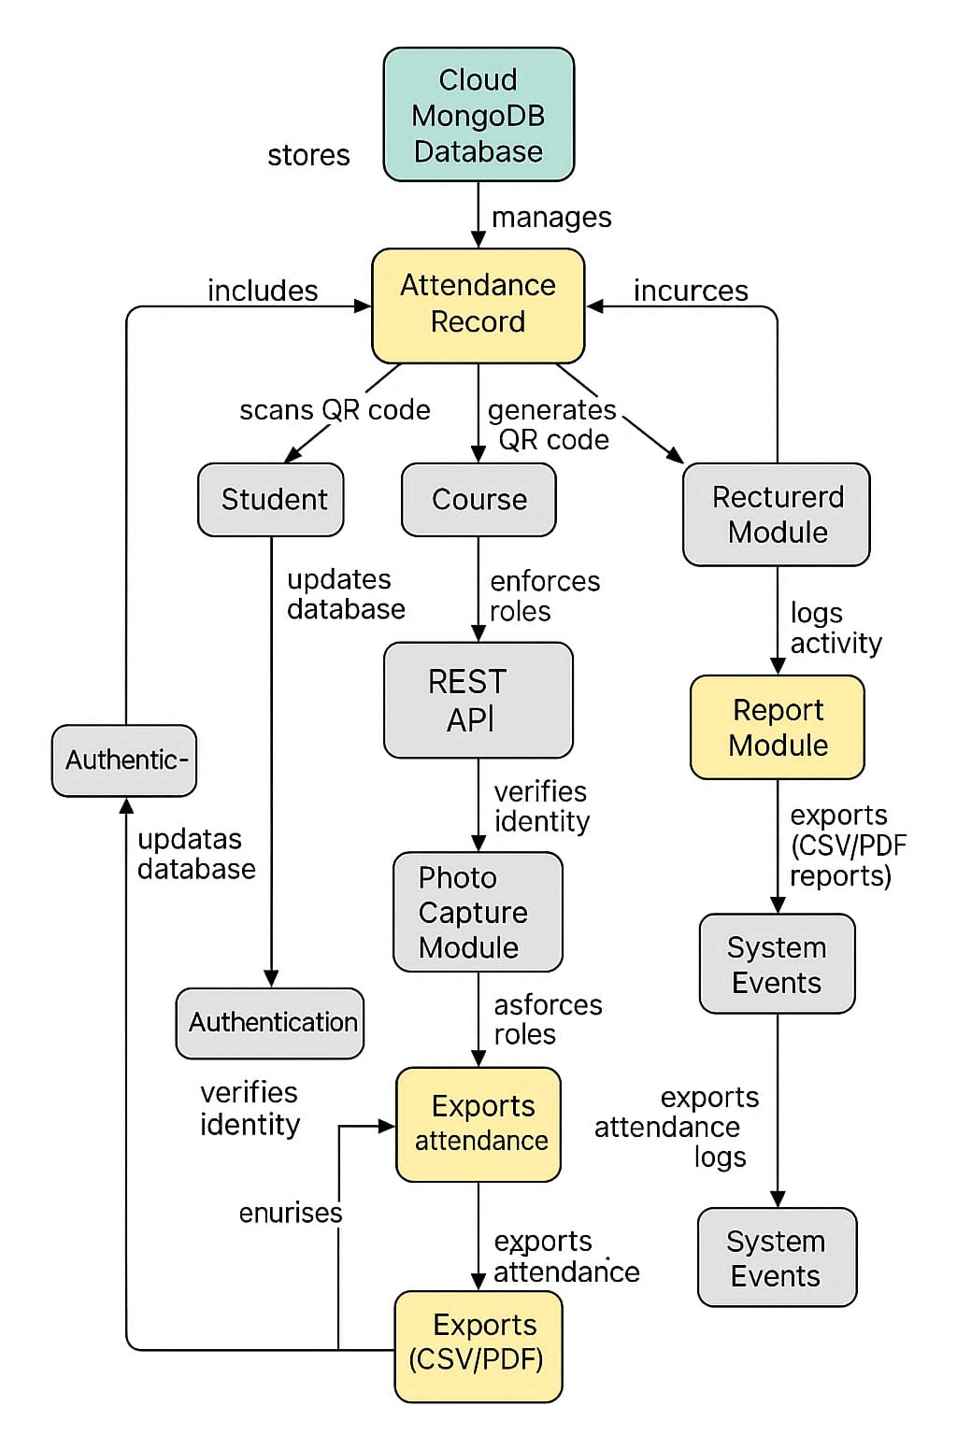

Student  
A student interacts with the system primarily to check in and view attendance records.  
  
Lecturer  
Responsible for generating QR codes, capturing student attendance, and managing their own registered devices.  
  
Admin  
Has full control over user accounts, system logs, and manages reporting and auditing.  
  
(Optional) Ancora  
  
This appears to be a label error in the diagram — possibly a misrepresentation of "Admin" or another actor.